**Final Report**

**IBM Case Study**

Group 1: Nehal Mishra, Parva Shah, Achal Shah, Felipe Montoya  
MG-GY 6303: Operations Management

Professor David Steven Jacoby

12/08/2022

New York University, Tandon School of Engineering

**TABLE OF CONTENTS**

1. **EXECUTIVE SUMMARY 3**
2. **INTRODUCTION 4**
3. **PROBLEM 6**
4. **ANALYSIS 7**
   1. **Process & Service Strategy 7**
   2. **LEAN Management & Agile 12**
   3. **Job Design & Human Resource Strategy 16**
   4. **Supply Chain & Sustainability 19**
5. **SOLUTIONS 22**
   1. **Process & Service Strategy 22**
   2. **LEAN Management & Agile 24**
   3. **Job Design & Human Resource Strategy 27**
   4. **Supply Chain & Sustainability 28**
6. **CONCLUSION 29**
7. **BIBLIOGRAPHY 31**
8. **EXECUTIVE SUMMARY**

IBM is a transnational corporation with multiplicity of locations, services and products. IBM is divided into three divisions: 1) IBM Consulting, 2) IBM Software and 3) IBM Infrastructure, the company is geographically located in The Americas, Asia Pacific and Africa/MENA/Europe with more than 200,000 employees in 2022.

IBM is a decentralized entity that has faced power dynamics and leadership conflicts causing different strategies in the organization in the last decade, amidst the loss of market share to Big Tech companies and massive layoffs within the company.

The company enters the 2020’s with Arvind Krishna as a new CEO, carrying out a massive process strategy shift, LEAN Management & Agile, HR Management, and Supply Chain & Sustainability measures to bring back IBM to the top positions regarding Cloud Storage services, Hybrid Data Centers, Consultancy Services and R&D in disruptive technologies such as Blockchain, AI and Machine Learning, Quantum Computing.

In Process Strategy, IBM transitioning from Job Shop to Process-Oriented and Mass-customization products and services and channel more than 70% of resources to IBM Software and IBM Consulting, with physical hardware and data centers underrepresented in the current strategy and with outstanding financial performance according to IBM Annual Report of 2021.

In LEAN & Agile Management, the company has created different tools such as IBM Garage, Simpler and Agile Lifecycle in different departments to provide consulting services versatiles to different industries; however, the company still faces impediments to apply and standardized agile methodologies within the organization globally.

Human Resources Management has faced different challenges such as upskilling, employee empowerment, well-being and talent management that can be identified and shifting course to claim back ranking positions as one of the best employer in the US.

Supply Chain Management & Sustainability in IBM needs to concretize in more pragmatical means across the departments and different locations in the organization, still sustainability is not completely penetrated in the majority of supply chain and processes in the day-to-day routine.

1. **INTRODUCTION**

IBM was founded in 1911, and since then, it has become a multinational corporation leader in providing IT hardware, software, and infrastructure consultancy services with a focus on B2C and B2B (IBIS World, 2022). The company operates in 174 countries, consisting of one of the biggest employers in the world, with more than 200,000 employees. After selling its PC segment to Lenovo in 2005, due to its complexity and size, the company is currently divided into five service streams: Global Technology Services, Global Business Services, Cloud and Storage Software, Systems, and Global Financing.

According to IBM’s technology and expertise, the proposal value in the company is divided into three channels: IBM Software, offering different integrations in data & Artificial Intelligence, automation, security, and Transaction Processing and Cloud Services (including Blockchain and the open-source Hybrid Platform Red Hat) it maintains constantly growing at a steady pace at 4% annually; IBM Consulting, providing a different set of products in optimization, agile organization, application operations and digital transformation across several industries and businesses becoming the top gainer in 2021 with annual growth up to 8%; IBM Infrastructure is the branch in charge of providing data centers, storage, and hybrid cloud services with IBM Z systems (z15 units) and power servers, the unit that has suffered a decline of more than 3% constantly (IBM, 2022).

IBM has made significant efforts to focus primarily on leading AI and Cloud services in the current market worldwide, emphasizing its strengthening in technological and infrastructure capabilities integrated across its segments offering services. The company has generated 57.4 billion USD in revenue and 12.8 billion in cash from operations, according to its most recent Annual Report. Regionally speaking, America's revenue grew by 4,4 percent yearly, Europe/MENA/Africa increased by 4.1 percent, and the last Asia Pacific grew by 2,8 percent (IBM, 2022). Its organizational structure is described below:

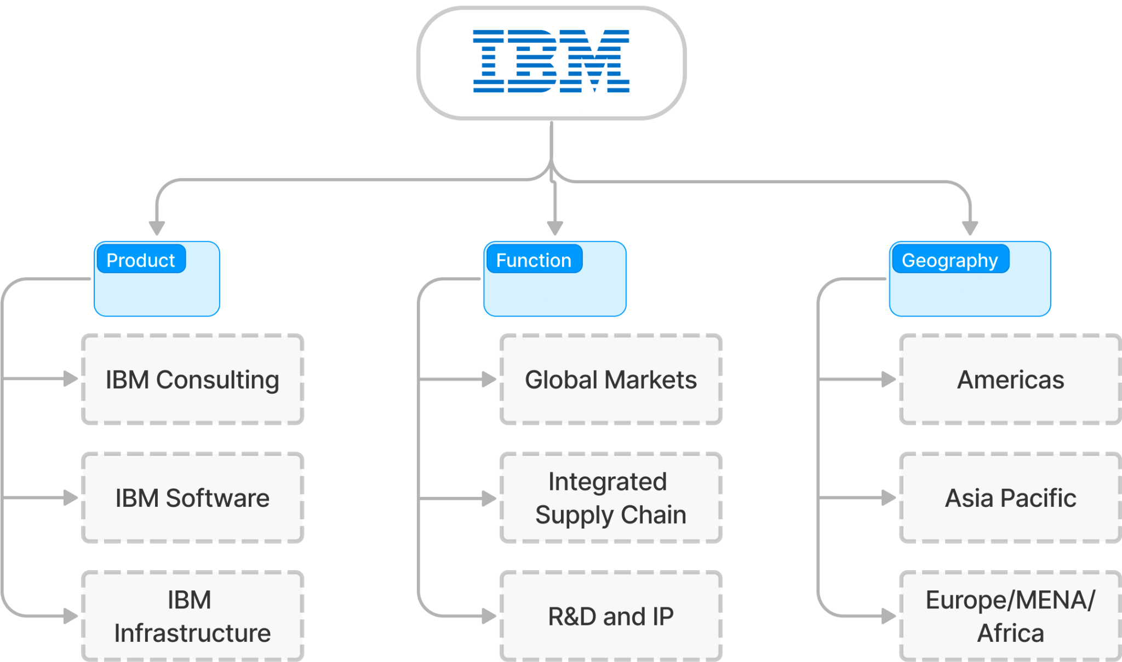

**Exhibit 1 - IBM Organizational Structure**

IBM faced tough performance challenges in the past decade, where it lost market share with competitors such as Microsoft and Amazon and consulting services competitors such as Accenture, Big4 companies, and even cloud storage service providers. By 2019, IBM witnessed how the revenue dropped each quarter for the past ten. The company was cutting quality, showing disappointing results that led to the market’s sensation that “The reputation IBM earned over a century was ruined in a few short years” (Forbes, 2014).

1. **PROBLEM**

IBM is a global entity, a leading company in hardware and software services. Even then, the management at IBM opts to have a decentralized structure across its many international branches. As a result, the company faces problems not only in its cloud-related products but also in its consultancy services. Due to this, IBM has lost a significant portion of its market share to newer technology companies such as Microsoft, Dell, and Amazon, among others. This is primarily because of their disoriented focus on innovation and sustainability. Apart from that, the company still needs to make their desired timelines in adopting Cloud services due to workforce shortages, thus causing internal layoffs. This, in turn, led to customer service and leadership deficiencies across different departments.

Furthermore, their employees need to be trained more to handle their disruptive technologies (such as AI, Blockchain & IoT). Decidedly, they must try and reskill efforts and employ proactive management to build the adequate customer support that their clients expect. Moreover, the sheer lack of workforce and innovation, along with their disregard for sustainability, has led to a supply shortage of IBM hardware. This has also affected some of their products in the blockchain, i.e., FoodTrust. Lastly, the company’s asynchronous efforts to address market demands have led to the discontinuation -or at least restructuring- of major IBM products like the TradeLens and FoodTrust and future Hybrid Hardware for Data Centers.

As the company is facing obstacles in HR and consultancy services along with Cloud products and sustainability issues in their hardware, it is essential matter to analyze the issue in four aspects: 1) Design of goods, services, and strategy, 2) LEAN and agile management in a multinational and complex organization that has been a significant player for more than a century 3) human resource management issues presenting in one of the biggest employers in US and world, and 4) Disrupted supply chain and lack of sustainability.

1. **ANALYSIS** 
   1. **PROCESS STRATEGY & SERVICE**

IBM platforms & products are focused on providing solutions for different processes & industries. The company faced difficult times last decade, supporting Arvind Krishna’s words, CEO of IBM, “*The bets of the past have not paid off. IBM Cloud as IaaS is gone, Watson did not deliver and Blockchain is too slow to keep thousands of consultants occupied*” (Crunchbase, 2020). Since then, IBM has changed its business radically in the last three years, transitioning to a Consultancy/Software-focused prioritization in its portfolio and reducing its exposure to hardware and data centers on the other, capitalizing on its innovation-focused business approach. AI and the Cloud are prevalent in today's digital world. IBM's mid-term plan is to dominate the hybrid cloud and AI.

**Solutions offered on the Macro-Level (Exhibit 2):**

The company is shifting its focus to IBM Software and Consulting. Ergo, the plan to adopt Digital Transformation internally is at the highest stake to topple competitors in the market segment. In this decade, IBM has raised solutions for the following issues:

Managing complexity grows as major businesses employ various heterogeneous IT infrastructures and clouds. IBM aims to provide a centralized solution for their clients rather than rely upon competitors' services such as AWS or Microsoft Azure.

Secondly, there is a need to obtain value from a boom in the amount of data accessible, which researchers predict may increase up to threefold over the next three years. For the company, this consists primarily in three specific areas: Big Data that groups IBM Public Cloud, AI Automation, and Natural Language, but also Hybrid Data Storage Infrastructure and finally disruptive technologies such as Blockchain and R&D in Quantum Computing as a long-term gamble for the next two decades.

Furthermore, ensuring competitive operations in the face of disruptive change and a lack of qualified workers. Precisely is the focus of IBM in AI-related services for supply chain: connected, programmed, self-reliant, and increasingly predictable with more efficiencies learning from the AI-based platform of Supply Chain Management by IBM, partnered with CIO.com. The core service is applying analytics software to make software predictions in obstacles, cyclical issues, recurrent errors, etc. By doing so, the SaaS will be able to forecast almost 100% of when the item is shipped. BASF is the pilot creating an algorithm to predict shipping with precision and forecast future ones.

It is also tackling the growing expense of cybercrime and the rise of destructive security breaches by offering System Integrator partners, blockchain-based encryption, SaaS solutions for firewall protection, and more. Also, the Linux-based Red Hat branch offers a robust cybersecurity framework that facilitates operations at a significant scale in the software industry.

Besides jointly overcoming such obstacles through an integrated, sustainable execution strategy, it is a proud founding member of COP 27, data analytics, and advanced technologies applied to make IBM one of the world’s greenest companies, with a green score of 100.

IBM has introduced a hybrid cloud to provide flexibility over heterogeneous environments and adapt proactively to the current trends in software & consultancy services. As a result, profit revenue increased by 6% last year, and over 70% of our annual income is in software and consulting, delivering healthy, sustainable growth (IBM, 2022).

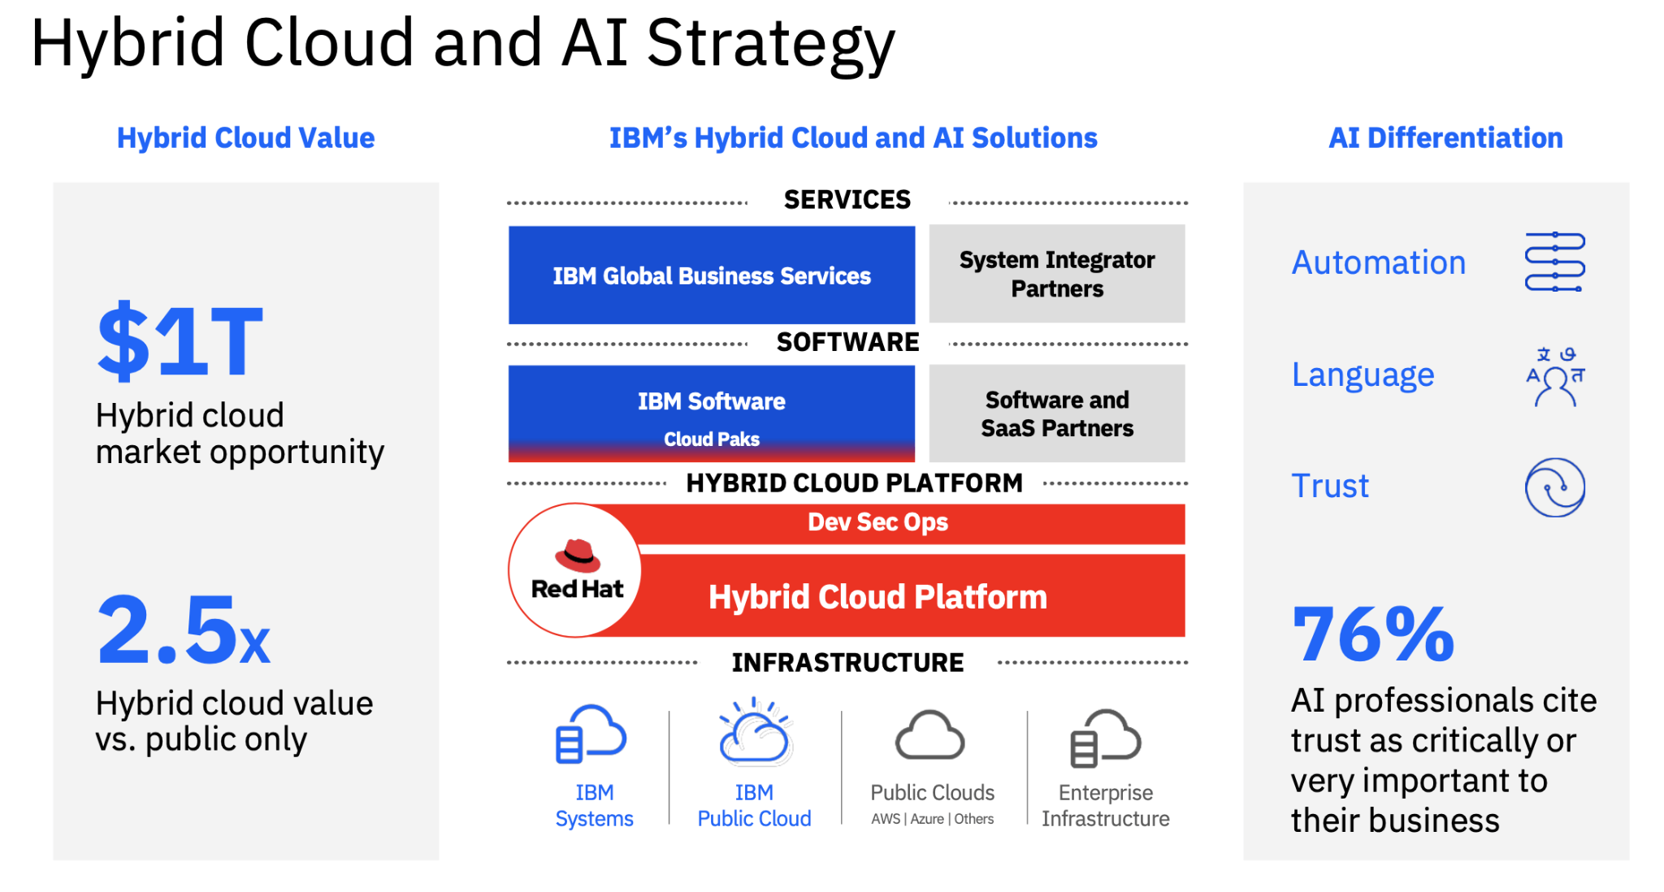

**Exhibit 2**

According to the company, this strategy generates 2.5 times more value for businesses than a public cloud-only strategy. It is intended to frame a differentiated architecture for Business Innovation B2B and B2C. The approach contains several advantages, including a) Creating and update for the hybrid cloud to create and run quickly, consistently, and agilely; b) Regardless of the location of the data, developing data-driven business insights while upholding enterprise-grade data governance, privacy, and trust; c) Automate corporate processes from beginning to end for effectiveness and efficiency with AI-driven decision-making; d) With uniform governance and compliance across environments, everything is secure; e) Bring it all together by developing sustainable best-in-class industry practices for our client's businesses and processes.

**Job Shop**

Job shops are used where there is wider variety, complexity, skill level, and scheduling complexity but lower volume and fixed costs. In one organization, IBM’s Job shop can handle any volume and price too:

Process-focused, IBM Consultancy creates different solution platforms from their Cloud Platform, and each bespoke platform (SaaS) is focused on providing solutions for various industries. According to Heizer, they are repetitively focused as post-consuming services are common for all clients with similar characteristics (See Exhibit 3).

Product-focused, IBM Software faces a high demand volume and is mainly standardized, according to Heizer. The Cloud products offer a continuous portfolio of highly homogenized services according to the Client’s profile and necessities: cybersecurity solutions, Watson predictability machine learning processes, data science, chatbots, cloud management, and SaaS Integration.

Make-to-stock IBM Infrastructure offers a wide range of Linux Servers linked to Hybrid storage of data (Cloud + Data Centers). The models are IBM z16, IBM Linux One Emperor 4, IBM Power E1080, Power E1050, and Power S102.

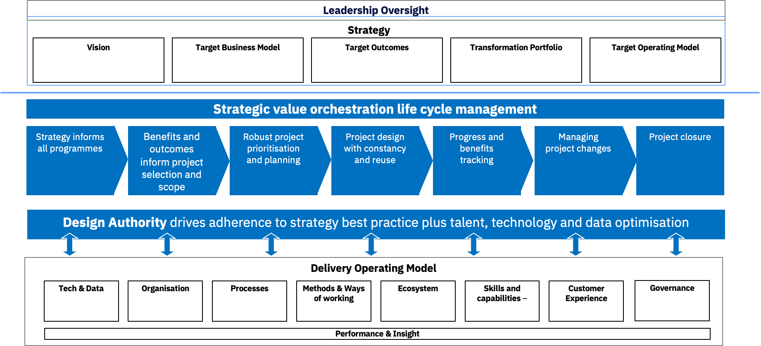

**Exhibit 3**

According to IBM Final Report in 2021, the concrete solutions at a micro-level for every company division can be summarized as follows:

1. Software: Software combines platform-optimized software solutions with IBM's hybrid cloud platform to help clients automate, protect, and modernize their environments
2. Consulting: Consultancy services offers thorough domain knowledge and the best business transformation and technology implementation skills. With SAP, IBM has developed new consulting services, while Deloitte and IBM have jointly developed an AI-enabled analytics solution. IBM established joint ventures with Telus, Cisco, and Palo Alto Networks.
3. Infrastructure: Infrastructure is the backbone of the hybrid cloud stack and offers dependable, flexible, and secure solutions. Remanufacturing and reselling obsolete equipment are additional infrastructure components emphasizing sustainable recovery services.
4. Financing: Through its financing solutions, Financing enables IBM clients to purchase information technology systems, software, and services.

**Challenges of this model:**

1. Application Dependency - When your servers, apps, or other technological elements depend on one another to operate, this is known as an application dependency. Users of IBM who couldn't previously connect or find solutions in their IBM settings now have those possibilities.
2. Cloud First Initiatives - Partners want to understand the transformation's business impact and methodology before adopting it and moving from the personal data centers they control.
3. Data Center Expenses - Upgrading may only sometimes be possible, and modernization is mostly too. IBM Data Centers in Dallas, Melbourne, and Seattle closed last year.
4. Hardware Refresh - Newer updates may be complicated as consumer applications are built on legacy systems. The hardware can also be prone to cyber threats.
5. Skillset Dependency - There needs to be more system administrators in the organization and the markets, as every company has specialized needs and requires training.
   1. **LEAN Management & Agile**

IBM adapted its methodology concealing LEAN principles with Six Sigma and has assigned IBM Global Business Services (now IBM Consulting) to deliver LEAN Six Sigma Strategy within the company and lead the implementation of efficiency frameworks across different industries and sectors.

IBM GBS LEAN contains tools that assist in identifying and eliminating waste (Muda), quality improvement, production time, and cost reduction. As part of this new approach by Arvind Krishna, current CEO, the Infrastructure department has faced a lot of pressure to stall production of excess inventory in Data Centers, especially IBM Power 1050 to focus more on the IBM z16 as a hybrid open-source data center solution. To solve these waste management issues, the LEAN strategy, since its inception, has considered the following items: a) continuous process improvement (*Kaizen*), b) the Five-whys, c) mistake-proofing (*poka-yoke*), d) techniques to improve “continuous flow,” including production leveling, e) “customer pull” employing Kanban and f) Heijunka Box.

IBM Simpler Business System® is devoted to contributing LEAN applications of efficient methodologies within the organization, with the philosophy of eliminating waste, creating value, improving process flow, and developing and documenting standard work, visual management, and pull systems (IBM, 2022).

Besides what is done by IBM Consulting, IBM Global Technology Services (now IBM software) developed its version combination of LEAN Six Sigma and Scrum principles and concepts to create its own ScrumBan version.

On the other hand, IBM® Global Technology Services® implemented Agile for Services (AFS) due to a joint force between Scrum Alliance and IBM Studios Singapore, where it was the first pilot of this new approach in the company (HBR, 2018). It is based on four pillars: Continuous Service Improvement (DevOps Backbone) is their software tool for the *kaizen* concept in LEAN Management.   
 The fit-for-use framework is not one-size-fits-all, meaning every process must mold the customers’ needs. Doing so guarantees that the framework is versatile enough to adapt to different problems and learn from previous mistakes; this is how the Poka-yoke corollary is adopted.  
 According to their service strategy, the prioritization must carry on AI & Data-driven inputs to facilitate a customized product that enables an efficient integration. This approach allows client co-creation, where the Agile teams within the company work together with the client to reconcile perspectives that will improve interest alignment in the product delivery.   
 As proof of the “Respect for the People” mantra in Heizer, IBM believes in employee empowerment. Therefore, IBM has developed Agile Teams across the Americas, Asia Pacific, and Europe/Africa. In the US, IBM has invested more than 300 Million USD in “Agile Hubs” in Austin, San Francisco, Atlanta, New York City, Cambridge, and Raleigh (Gillin, 2021).

Regarding departments, IBM has seceded part of its agile consultancy services to a whole entity named Simpler; a team-based enterprise focused on continuous improvement with an emphasis on eliminating non-value-added activities or “waste” from the viewpoint of the customer. IBM has been using Lean tools in manufacturing but recently applied them to supply chain and software management.

Simpler has developed an exciting tool based on the principle of Gemba in LEAN. It is designed as a detail-oriented visit by IBM’s LEAN Engineers where it states insights, tips, and efficiency trick recommendations to apply for the company waiting to enhance their efficiency.

IBM and Simpler pilot Inland Health Empire Program (IEHP) as an SVP designed to overtake the consultancy services for health organizations which are segmented into two categories as such: provider services and member services. IBM left the paper-based inefficiencies and adopted new digital tools that built new metrics & backlogs to follow and evaluate throughout a long-term timespan. Indeed, the best way IBM can make a case is by advertising itself and the transformations made internally to establish more efficiencies.

Notwithstanding, the agile management in IBM has presented some aspects that deserve improvement, related to tangible data that support their results and a lack of centralization across the organization, some of the issues are as follows:

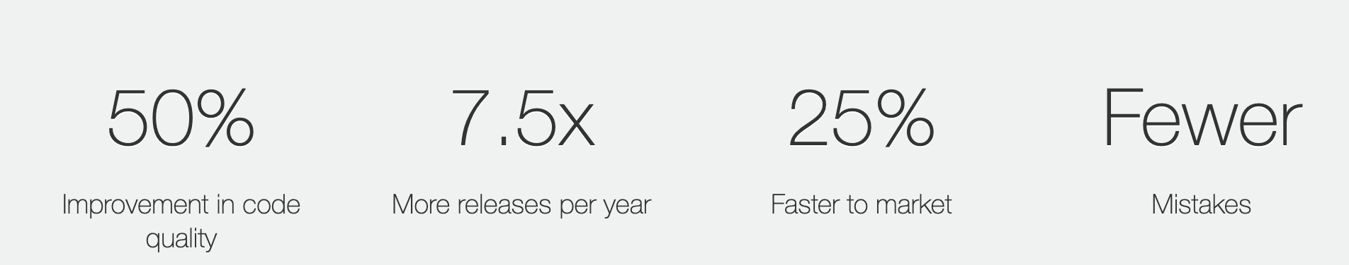

**Exhibit 4**

The Simpler team affirms 70% velocity improvement responses for customer services are granted because of the application of agile processes, and the DevOps team confirms they have had an improvement in 50% of code quality, 7.5 times more releases per year, and fewer mistakes, it is very vague the assertion and cannot be contrasted with transparent data in the case of IBM (See Exhibit 4).

According to the report, only 34% of IBM’s processes apply Agile methodology by 2019. Although this phenomenon is changing rapidly due to an incremental focus from the Board directors on efficiency and cost-cutting, IBM has not attained the 68% goal of processes implementing agile techniques or any sort of Lean methodologies (See Exhibit 5). The more it is implemented in-wards, the more accountability is provided by future clients.

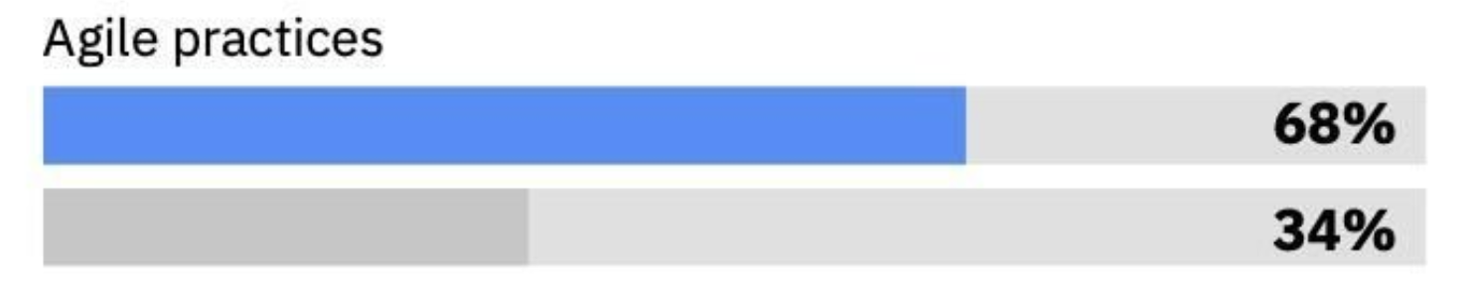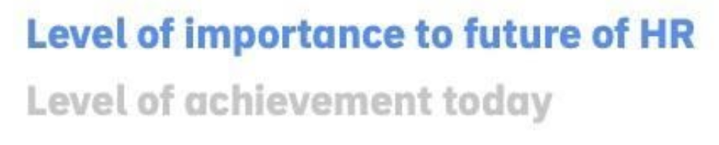

**Exhibit 5**

Another issue is that Simpler® Consulting acts entirely independently of the Agile Team. The most essential use case to sell LEAN implementation is the adoption of the Simpler tool across IBM, not only in their global Headquarters but guaranteeing it is embedded and implemented in different countries. How they will deal with cultural clashes and paradigm shifts would be the best output in a consultancy with a Simpler Customer, they have developed another two tools of agile within different departments and geographic locations: a) Agile Lifecycle Management program for DevOps (currently in version 2.2.0) as a dashboard created for project managers working alongside development teams, and b) IBM Garage Methodology which implements reliability into their software components, applying the Salesforce partnership it aims to Maximize investment through a holistic approach to transformation and explore how to unlock the next wave of value.

The agile initiative in IBM is highly decentralized and lacks interconnectedness. The company needs to build bridges that assure the different teams across geographical zones and departments to implement agile techniques that a) are helpful for clients and b) provide efficiency within IBM as an organization. Currently, we see a disparity between IBM Software and IBM Consulting that makes sense when you have a widespread service portfolio but is not desirable regarding operation processes for the company itself.

From our research, we have concluded that IBM follows three principles in order to make their software more reliable, namely redundant resources, degraded results, and retry transient failure.

1. Redundant resources:- In this pattern, you trade cost for reliability. The first principle of reliability is to have redundant resources to avoid single points of failure. Every component can fail, but the system is robust enough to tolerate an individual outage.
2. Degraded Results:- Some services may be willing to sacrifice quality for reliability. Businesses can tolerate some requests failing rather than expecting all transactions to succeed.
3. E.g.- Search system: people who run the query and don't get the result in time run the question again. If they need to retry once, they might consider it acceptable. However, if the need to retry reaches a certain level, people will complain.
4. Retry transient failures- In this pattern, you trade latency for reliability. Automatic retries contribute to continuous improvement and remove impediments constantly.
   1. **JOB DESIGN AND HUMAN RESOURCE STRATEGY**

After conducting a thorough analysis of IBM, we found several loopholes in the human resource department there. Our results suggest that to retain their talent and stop more employees from leaving, they need to invest back into their HR and global services department. Most of their issues originate at the executive level- where maximizing profit has always been the top priority. As a result, Global Services is in trouble, and IBM needs to take this organization's reconciliation seriously.

As we know, all divisions of IBM are losing talent worldwide. It is impossible to keep good employees who are underpaid, unappreciated, and have endured years of maltreatment. There are also some major communication problems within the internal teams, which leads to a disconnect between managers and workers. 74% of the employers at IBM claim that they help their employees reskill. However, when asked, 62% of the employees disagree with this statistic and believe they are provided with no help with reskilling whatsoever. Another example is that 80% of employers stated that they support their employee's mental and physical well-being. Only 46% of employees, on the other hand, agree with that statement. This means that more than half of their employees feel neglected and disregarded by managers, the latter being utterly ignorant of these issues.

Furthermore, the vast majority of IBM's 400,000+ employees are no longer employed by the business. Unhappy workers need to provide quality results. A large portion of the problem also stems from 51% of employees believing that the organization lacks internal transparency. Although they know that IBM is losing touch with their clients, there is little they can do to stop it.

Naturally, employees want to work for leaders who actively support their physical and mental health. However, they are let down by a management concerned only with maximizing profits. This has further created organizational complexity, a lack of good talent, and mass burnout at IBM. The problem that IBM faces is not just about skills but also the sustainability of those skills. In today's world, it is challenging to acquire new talent in the IT industry. It is even more tough to grow said talent exceptionally.

Our analysis points to the fact that the customers end up suffering from this internal disconnect at IBM. This is primarily because IBM needs to provide them with employees that have the necessary information to manage their complaint applications for one of two reasons- lack of skilled staff in the customer service department or the inability to retain workers overall. Lastly, we have analyzed IBM’s problem areas within various segments that affect Human Resources directly. ( See Exhibit 6)(Mendoza, N. F., Staff, T. R., Abdullahi, A., Shacklett, M., Greenberg, K., & Stone, B. (2020, October 19).

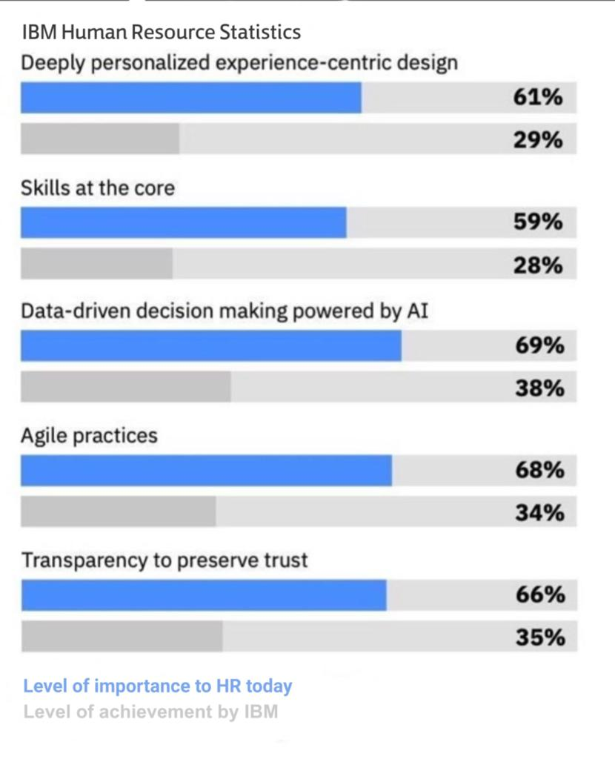

**Exhibit 6**

The detailed analysis of IBM’s business model and job design strategy highlighted another major issue: IBM changed many employees, leading to their overall decline. IBM has a wayward business model of starting new subsidiaries and selling them as soon as the business starts making a profit. Meanwhile, the employees of that business must relocate, and the employees who were savvy about potentially losing their jobs may have been able to act quickly to get into a position that was a bit more stable, but others were not so lucky. When IBM opens a new company, it needs to hire new personnel. Because those new employees require some sort of onboarding, this could become a problem. They are unaware of IBM's culture, which results in less productivity, and slow productivity prevents a company from earning the profit it could.

Along with this, some IBM employees feel insecure because of everything mentioned above. Every year, IBM drops out of particular market segments, negatively impacting employee morale as they feel unsure about staying at IBM until retirement. It results in IBM losing stellar employees to its competitors who provide better job security and a sense of importance within the organization (Bloznalis, S.,2022, September 16).

* 1. **SUPPLY CHAIN AND SUSTAINABILITY**

IBM has a global and very complex supply chain with manufacturing facilities that are spread around the world. They have employees in about 50 countries. IBM Supply Chain operates in a hybrid model consisting of build-to-plan and build-to-order. From our analysis, we can say that from the six major sourcing strategies, IBM has adopted the “many suppliers” sourcing strategy. IBM integrates social and environmental responsibility into its relationships with approximately 14,000 suppliers in around 100 countries. They understand the potential for progress in a supply chain of this magnitude and invest in various initiatives to promote sustainable performance as a common goal. (IBM,2022)

Regarding sustainability, IBM is a proud member of COP27; it uses data to drive its sustainable development strategy. Its strategy is based on three key concepts: Define, Establish and Operationalize. In terms of Corporate Social Responsibility, we can measure IBM’s impact in terms of Environmental, Social, and Corporate Governance (ESG) as follows: 1)Environmental Impact: The company has committed to reducing pollution, minimizing risks related to the climate and also focusing on conserving natural resources. The company aims to reach net-zero greenhouse gas emissions by 2030, Divert 90% of IBM’s total non-hazardous waste by 2025, and Initiate 100 client engagements or research projects by 2025 in which IBM solutions have enabled demonstrable environmental benefits. 2)Social/Equitable Impact: IBM’s social work focuses on diversity and inclusion, supply chain social responsibility, and community development for the workforce. They aim to include 30 million people by 2030, log 4 million volunteer hours by 2025, 15% of supplier spend to black-owned suppliers, and 3)Ethical Impact: The focus is business ethics, corporate governance, and taking responsible technological initiatives. The company aims to provide technical ethical education to 1000 partners by 2022 and engage 100% of their suppliers on exemplary business practices. (IBM Sustainability Report, 2022)

However, there are a lot of issues within the supply chain management and sustainability that stem from our leading problem, which is the decentralized structure across IBM’s many branches and points with the management of their employees. According to IBM’s supply chain department employee (current and old) opinions on various major job portals, there are mentions of the following problems:

1. Role and team responsibilities need to be clearly defined, there may be in peril to have duplicated roles and responsibilities. Also this will disincentivize commitment to sustainability activities.
2. Direct managers in different locations around the world resulting in communication problems
3. Lack of communication between many layers of management
4. Issues take a long time to be addressed (Indeed, 2018)

These issues have plagued IBM’s Supply chain and sustainability goals in various ways, such as:

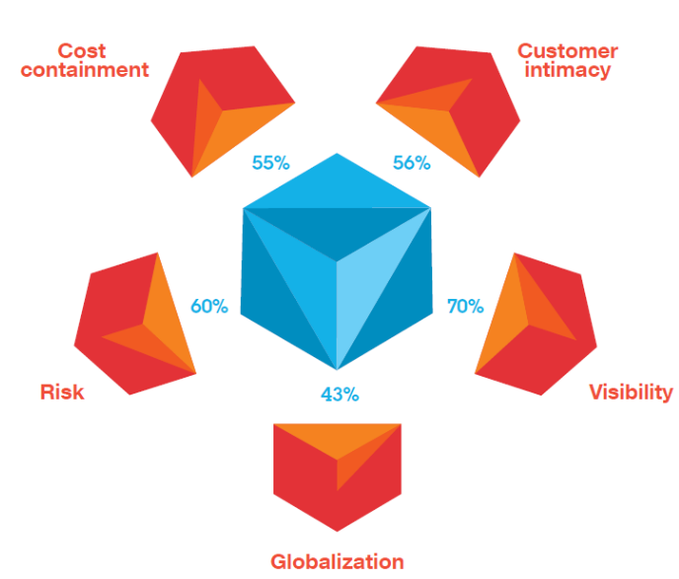

**Exhibit 7: IBM’s Five Main Supply Chain Challenges**

According to Exhibit 7, one of the main challenges of IBM’s Supply chain is “visibility”(Atul,2011). Even though IBM has continued to focus on technological enhancements, the lack of visibility worldwide and timely information to make decisions remains a significant issue. Decision-making delays are related to mismanagement and communication problems across various teams. A classic example of this is TradeLens. TradeLens, launched by IBM and Maersk, is shutting down in Q1 2023. (Dan Robinson,2022) TradeLens was found to solve problems related to inconsistencies with data across supply chains in the shipping industry and used the latest blockchain technology; however, it was unable to deliver the promised business value. From our analysis, there are other issues in Supply chain and sustainability, such as IBM not making it to the list of the top 15 companies with the best CSR policy, and more than 73% of millennials prefer working for a company with great CSR policies. Adidas currently ranks #1. (Sally Acquire, 2022)

There is a massive emphasis on supply chain agility; however, agility is sort of a confusing concept among the employees, and it refers to quick problem-solving for the customers and shortening the response time, nonetheless, due to mismanagement at the top level, is difficult for other teams to understand this and be on the same page.

**4. SOLUTIONS**

* 1. **PROCESS STRATEGY & SERVICE**

IBM is an innovative company and has pivoted successfully many times in the past; a lot of services could be doing better, including Blockchain products and some Hybrid Data Centers (particularly IBM Power E1050). According to the IBM Annual Report of 2021, there has been a 3% decline in revenue in IBM Infrastructure in 2022.

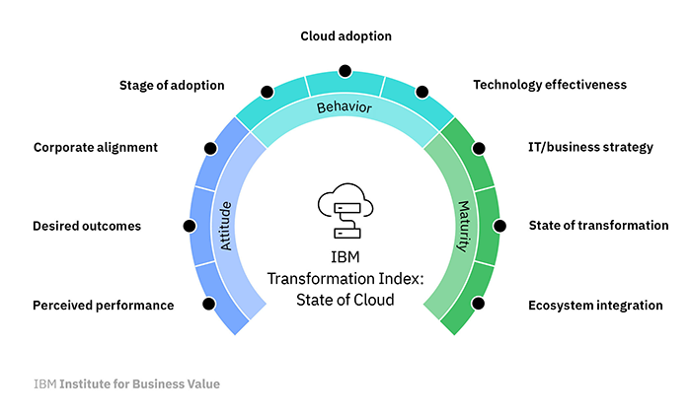

**Exhibit 8**

Help partners understand the business impact of Transformation in a hybrid cloud and clear all skepticism. It is unclear to business partners the business impacts hybrid cloud will have on their business metrics and clear suspicion. Private data centers allow companies to have full control over their data cycle. IBM needs to clear doubt that moving from private data centers to a hybrid cloud will affect business stakeholders.

Train more system administrators per requirements and tie up with universities to train and hire fresh system administrators. There are specialized engineers for other cloud services in the job markets, but there are few system engineers/administrators. There needs to be more training, even for the already existing engineers at IBM. IBM needs to concentrate on this and enable more training in company engineers, offer certifications on Moocs services such as Coursera and tie up with computer science programs across various universities to train more freshers as system engineers/administrators.

Limit the number of services offered to those doing well and offer more customization in which the organization specializes. To elaborate, some of the IBM services are doing poorly. For example, FoodTrust is going to shut down. IBM needs to decide on services that are its strength and shut down services that could be doing better. Instead, those resources can be used to concentrate on offering services that are its strength, and it wants to focus on overcoming years such as hybrid cloud and artificial intelligence.

This will enable the Strategy to be between Job Shop and Mass Customization. This way, it can concentrate on being flexible and differentiated simultaneously. This tradeoff will help IBM to become a bridge between consulting and technology.

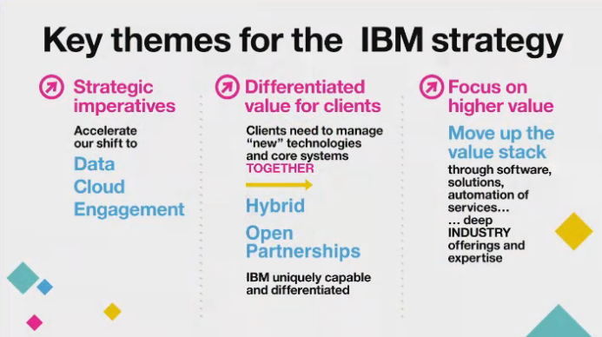

**Exhibit 9**

To summarize, competing directly with existing players in the space is difficult, such as Amazon Web Services, Microsoft Azure, and Google Cloud Platform.

Therefore, the target space between Job Shop and Mass Customization is to offer Cloud services through Consulting Services. With SAP, IBM has developed new consulting services, while Deloitte and IBM have jointly developed an AI-enabled analytics solution. IBM established joint ventures with Telus, Cisco, and Palo Alto Networks. IBM has already entered that space but needs to focus more on this path. It can further partner with one of the top consulting firms out of McKinsey & Company, Boston Consulting Group, Bain & Company, or Ernst & Young.

* 1. **LEAN MANAGEMENT & AGILE**

Lean principles give IBM’sprofessionals a competitive advantage in departments such as Health, Supply Chain, Logistics, automation consulting, Cloud services, and consultancy services. Its focus on supporting strategies based on Differentiation, Responsiveness, and Cost Leadership is essential for the future of

IBM also drives Lean Operations by taking Six Sigma concepts to the next level, and its key focus is on efficiency and growth. IBM invested heavily in Lean Six Sigma initiatives that initially involved an intense period of training initially resources and a different set of projects to jumpstart their transformation. Their early adoption of the methods gave them a competitive edge.

In the future, IBM should focus on investing in Lean and Sustainable strategies combination and on internal and external issues. They should also look into eliminating environmental waste in the eliminating waste step.

All of it is plausible, yet IBM agile efforts have been disintegrated internally speaking IBM Singapore has led initiatives to run Scrum Agile with Scrum Alliance. The IBM Evan Leybourn states that the company needs to make more practical efforts to standardize and penetrate cultural organizations' agile practices in day-to-day routines. The executive quoted: “Sometimes you just have to jump out of the window and grow wings on the way down” (Scrum Alliance, 2017). On the other hand, IBM Garage is a tool that,, according to Debbie Vavangas IBM executive, is “It’s a framework that brings innovation into the heart of your enterprise that combines lean startup, continuous improvement, agile development, design thinking and IBM’s suite of capabilities to enable digital transformation faster.” (Silicon Angle, 2021). On the other side, you have the IBM Simpler tool as an agile methodology focused mainly on Health Industry optimization, and it’s a completely separate entity. Finally, the Agile Lifecycle Management tool (v 2.2.0) is a backbone dashboard designed for Project Manager DevOps in software development teams, vastly used in IBM Software and specifically in Red Hat products. These are a compilation of different solutions that IBM has designed to carry out different practices in different industries. It is highly intuitive and practical, but it requires unified guidelines throughout the organization.

It is essential to adopt a scalable solution to communicate with several IBM departments across three geographical zones (Americas, Asia Pacific, Europe/MEAN/Africa); this methodology should include aspects of the fit-for-use framework and transition agile methodology to upscale processes and standardize with efficiency its products.  
IBM Garage's widespread adoption may solve the lack of data, and this may ease up the impact of Agile adoption as more transparent and quantifiable. This is a recurrent issue with many consultants because they must be reliable and accountable for implementing these principles internally across the organization. By doing so, IBM is assuming a leadership that may mean a significant market share in the efficiency consultancy services.

IBM should execute an adjustment version of Scrum of Scrums following the LEAN principles across different geographies and departments. The different Agile Teams, IBM Garage, Simpler, and Lean Engineers must designate Ambassadors that coordinate at a macro level within IBM Corporation as a whole but also its different divisions as global entities, rather than companies insulated to its local dynamics. The dynamics for Scrum of Scrums are illustrated in Exhibit 10 as follows:

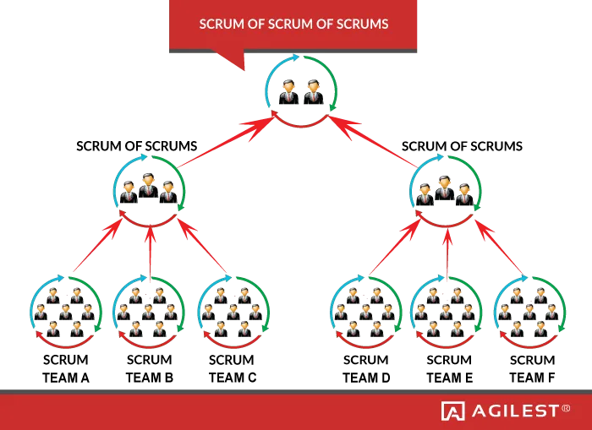

**Exhibit 10**

Scrum of Scrums, or its own IBM adaptive version combining Lean Management, is a more than a scalable solution to communicate with several IBM subordinates, leading to cultural clashes, paradigm shifts, and different time zones.  
Implement Agile and Disruptive Technologies (R&D)  
IBM should execute an adjusted version of Scrum of Scrums following the LEAN principles  
Due to IBM Garage practices, IBM Consulting was up 8% by revenue in constant currency. Imagine what could be done if the strategy is internalized across the entire organization.

* 1. **HUMAN RESOURCE MANAGEMENT**

Our research offers plenty of solutions to IBM's ongoing human resource crisis. The main point presented here is that IBM should stop cutting staff and start doing things essential for any company to retain good workers. IBM has too many employees managing their applications, but only a few provide services for those applications. This implies that IBM needs to restructure its business process design majorly. Several techniques, like creating Visual workspaces, Appropriate labor planning policies, and Work sampling techniques, can be the first step towards a significant restructuring (Cringely, R. X. 2014, October 28).

From our detailed analysis of IBM, along with studying HR concepts on Heizer, we come up with ten action areas where IBM needs to work on the most to cement itself back as one of the most successful and most significant employers in the global IT sector ( See Exhibit 11) (Mendoza, N. F., Staff, T. R., Abdullahi, A., Shacklett, M., Greenberg, K., & Stone, B. (2020, October 19).

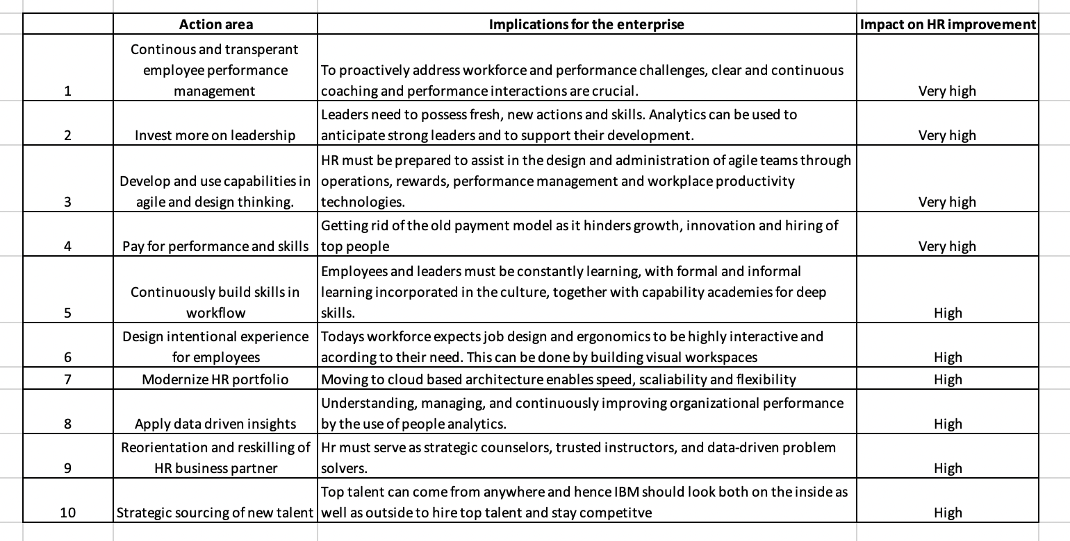

**Exhibit 11**

The report identified ten action areas, the repercussions for the enterprise and the impact of the actions if carried out. The action areas include continuously and transparently measuring employee performance, investing in the new leadership role, developing and applying capabilities in agile and design thinking, paying for performance and skills transparently and equitably, constantly developing skills in the flow of work, designing intentional experiences for employees, reshaping the HR technology portfolio, applying data-driven insight and understanding, reorienting and reskilling HR business partners. The first four have a "very high" impact, while the rest have a "high" impact (Mendoza, N. F., Staff, T. R., Abdullahi, A., Shacklett, M., Greenberg, K., & Stone, B. (2020, October 19).

* 1. **SUPPLY CHAIN SUSTAINABILITY SOLUTION**

In terms of supply chain and sustainability, the proposed solutions from our research could be found in Heizer's “Managing the integrated supply chain.” (Heizer et.al., 2021) The answer here is to focus on CPFR, i.e. Collaborative Planning, Forecasting, and Replenishment. The primary issue with IBM is they have teams and employees spread across the globe and managers in different locations, so with CPFR, employees and members of the supply chain will be able to share planning, demand, forecasting, and inventory information. CPFR can help to reduce the bullwhip effect significantly. In terms of sustainability, the solution is maintaining ethical behavior towards the environment. (Heizer et al,,2021). Business relations with suppliers must be maintained only if the supplier does their business in a way that supports the conservation of the environment and meets sustainability laws. In the future, IBM can focus on making sustainability a core practice and only tie up with suppliers who follow their sustainable goals and have a CSR policy.

**5. CONCLUSION**

IBM is a complex company with a presence on every continent and more than 250,000 employees as of 2022. Last decade faced constant challenges due to the rise of several incumbents in software and hardware products, such as Big Tech and Asian Data Centers manufacturing companies. Yet the company in this decade has demonstrated resilience and has made a shift in investment, prioritizing disruptive technologies, Cloud services, Software, and Consultancy top-notch services.

For Service & Process Strategy is recommended more training of existing system administrators and, hiring more administrators, flexibility, partnerships with more organizations, and offering mass customization in consultancy services that integrate AI & data-driven products to provide a differentiated factor compared to competence.

Regarding LEAN Management & Agile, IBM is highly decentralized -and usually- asynchronous in agile practices across every service: IBM Consulting, IBM Software, IBM Infrastructure, Simpler®, IBM Garage, and Agile Lifecycle teams need to apply scalability to coordinate as a whole using Scrum of Scrums adaptive version according to company’s necessities.

Regarding HR Management, IBM should focus on improving work measurement strategies, invest more in leadership, hire employees more strategically, enhance ergonomics and workspaces within the organization, try implementing people analytics to improve workflow, and lastly, pay the employees based on their performance.  
Finally, in Supply Chain & Sustainability Focus should be on making sustainability a core practice, focusing on open innovation, CPFR, and focusing on process improvement that ensures supply chain agility and faster response time. They need to comply with the assured paramount compliance with ISO 140001 and 50001 in environmental management spread through the entire company.

**BIBLIOGRAPHY**

Bloznalis, S., (2022, September 16). *Driving a cultural transformation: IBM's performance development journey*. From https://www.workhuman.com/blog/driving-a-cultural-transformation-ibm-s-performance-development-journey/

Calabria, T. (2022, April 1). Cloud Storage Services in Australia. Retrieved December 15, 2022, from IBISWorld.com.

Cringely, R. X. (2014, October 28). *How to fix IBM*. Forbes. https://www.forbes.com/sites/robertcringely/2014/10/23/how-to-fix-ibm/

Gillin, P. (2021, February 1). *IBM Garage's agile techniques are remaking the company's Services Unit*. SiliconANGLE. Retrieved December 16, 2022, from https://siliconangle.com/2021/01/29/ibm-garages-agile-techniques-remaking-companys-services-unit/

Heizer, J., Render, B., & Munson, C. (2017). Principles of Operations Management: Sustainability and Supply Chain Management. Pearson Education Limited.

IBM. (2018, May 7). *The New Lean, Agile Face of Business*. Harvard Business Review. Retrieved December 16, 2022, from https://hbr.org/resources/pdfs/comm/ibm/TheNewFaceofBusiness.pdf

*IBM's top Five supply chain challenges*. Enterra Insights. (n.d.). Retrieved December 16, 2022, from https://enterpriseresilienceblog.typepad.com/enterprise_resilience_man/2011/04/ibms-top-five-supply-chain-challenges.html

Lavrouk, S. (2019, March 15). *IBM has significant problems*. GuruFocus.com. Retrieved December 16, 2022, from https://www.gurufocus.com/news/833146/ibm-has-significant-problems

Mendoza, N. F., Staff, T. R., Abdullahi, A., Shacklett, M., Greenberg, K., & Stone, B. (2020, October 19). *IBM report: Employees say they lack skills, support, and transparency*. https://www.techrepublic.com/article/ibm-report-employees-say-they-have-a-lack-of-skills-support-and-transparency/

McDowell, C. (2022, May 9). *Thoroughly modern: The real top 5 challenges for IBM i shops today*. IT Jungle. Retrieved December 16, 2022, from https://www.itjungle.com/2022/05/09/thoroughly-modern-the-real-top-5-challenges-for-ibm-i-shops-today/

McKenzie, J. (2020, January 14). *Why Blockchain won't fix food safety-yet*. The Counter. Retrieved December 16, 2022, from https://thecounter.org/blockchain-food-traceability-walmart-ibm/

Miller, R. (2020, May 22). *IBM confirms layoffs are happening, but won't provide details*. TechCrunch. Retrieved December 16, 2022, from https://techcrunch.com/2020/05/22/ibm-confirms-layoffs-are-happening-but-wont-provide-details/

Robinson, D. (2022, December 2). *IBM, Maersk will shut down Tradelens Supply Chain Platform*. The Register® - Biting the hand that feeds IT. Retrieved December 16, 2022, from https://www.theregister.com/2022/11/30/ibm_and_maersk_tradelens_shutdown/

Steve, D. A. (2011, April 25). *IBM's top Five supply chain challenges*. Enterra Insights. Retrieved December 16, 2022, from https://enterpriseresilienceblog.typepad.com/enterprise_resilience_man/2011/04/ibms-top-five-supply-chain-challenges.html

Thomas, L. (2022, July 1). Industry Report. Data Processing & Hosting Services in the UK. Retrieved December 16, 2022, from IBISWorld.com.

Tracey, S. (2022, January 10). *Cultivating relentless supply chain agility at IBM*. Recently Filed RSS. Retrieved December 16, 2022, from https://www.scmr.com/article/cultivating_relentless_supply_chain_agility_at_ibm